Source Code: activity_main.xml

<?xml version="1.0" encoding="utf-8"?>  
<LinearLayout xmlns:android="http://schemas.android.com/apk/res/android"  
 xmlns:tools="http://schemas.android.com/tools"  
 android:layout_width="match_parent"  
 android:layout_height="match_parent"  
 android:paddingBottom="@dimen/activity_vertical_margin"  
 android:paddingLeft="@dimen/activity_horizontal_margin"  
 android:paddingRight="@dimen/activity_horizontal_margin"  
 android:paddingTop="@dimen/activity_vertical_margin"  
 android:orientation="vertical"  
 tools:context="com.hakolab.myservice.MainActivity">  
 <Button  
 android:id="@+id/btn_start_service"  
 android:layout_width="match_parent"  
 android:layout_height="wrap_content"  
 android:text="Start Service"  
 android:layout_marginBottom="@dimen/activity_vertical_margin"/>  
 <Button  
 android:id="@+id/btn_start_intent_service"  
 android:layout_width="match_parent"  
 android:layout_height="wrap_content"  
 android:text="Start Intent Service"/>  
</LinearLayout>

Source Code: MainActivity.java

package com.hakolab.myservice;  
  
import android.support.v7.app.AppCompatActivity;  
import android.os.Bundle;  
import android.view.View;  
import android.widget.Button;  
  
public class MainActivity extends AppCompatActivity implements View.OnClickListener {  
 private Button btnStartService;  
 private Button btnStartIntentService;  
 @Override  
 protected void onCreate(Bundle savedInstanceState) {  
 super.onCreate(savedInstanceState);  
 setContentView(R.layout.activity_main);  
 btnStartService = (Button)findViewById(R.id.btn_start_service);  
 btnStartService.setOnClickListener(this);  
 btnStartIntentService = (Button)findViewById(R.id.btn_start_intent_service);  
 btnStartIntentService.setOnClickListener(this);  
 }  
 @Override  
 public void onClick(View v) {  
 switch (v.getId()){  
 case R.id.btn_start_service:  
 break;  
 case R.id.btn_start_intent_service:  
 break;  
 }  
 }  
}

Tampilan:

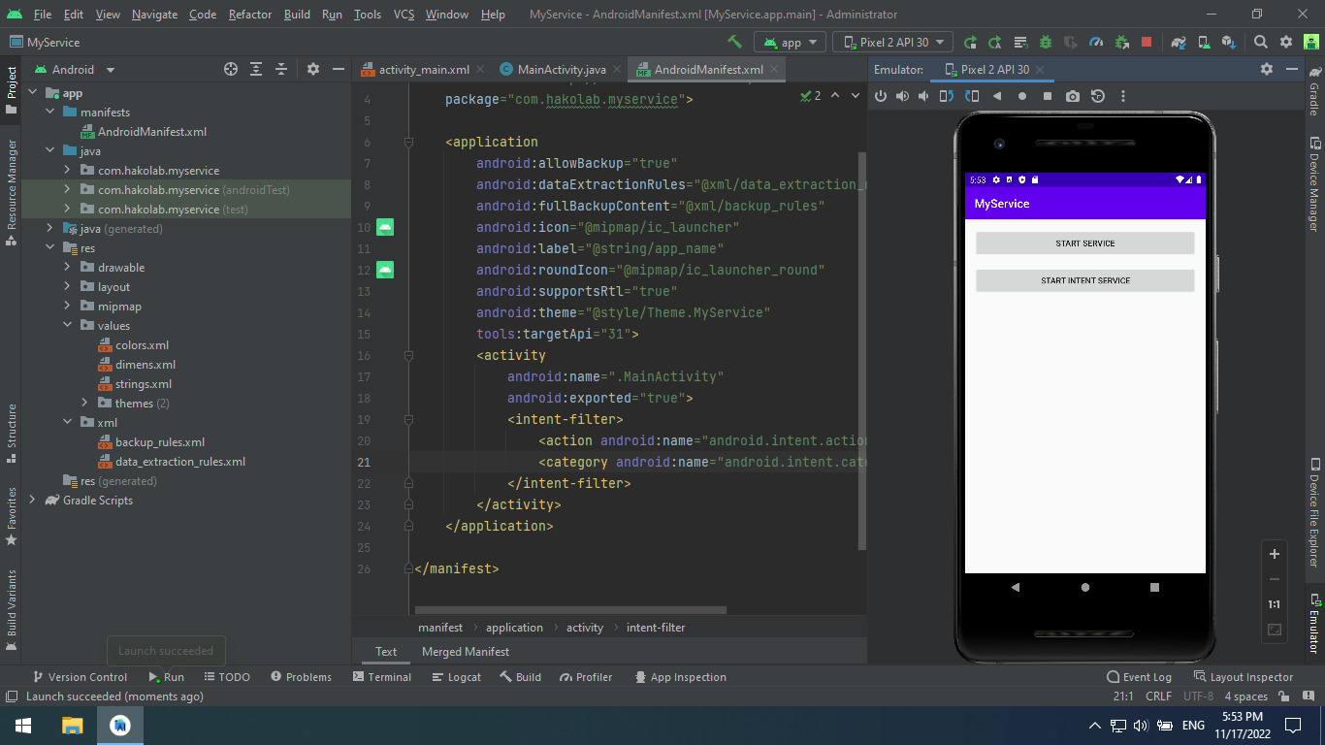

Source Code: AndroidManifest.xml

<?xml version="1.0" encoding="utf-8"?>  
<manifest xmlns:android="http://schemas.android.com/apk/res/android"  
 package="com.hakolab.myservice">  
 <application  
 android:allowBackup="true"  
 android:icon="@mipmap/ic_launcher"  
 android:label="@string/app_name"  
 android:supportsRtl="true"  
 android:theme="@style/Theme.MyService">  
 <activity  
 android:name=".MainActivity"  
 android:exported="true">  
 <intent-filter>  
 <action android:name="android.intent.action.MAIN" />  
 <category android:name="android.intent.category.LAUNCHER" />  
 </intent-filter>  
 </activity>  
 <service  
 android:name=".OriginService"  
 android:enabled="true"  
 android:exported="true">  
 </service>  
 </application>  
</manifest>

Source Code: OriginService.java

package com.hakolab.myservice;  
  
import android.app.Service;  
import android.content.Intent;  
import android.os.IBinder;  
import android.util.Log;  
  
public class OriginService extends Service {  
 public static final String *ORIGIN_SERVICE* = "OriginService";  
 public OriginService() {  
 }  
 @Override  
 public IBinder onBind(Intent intent) {  
 // *TODO: Return the communication channel to the service.* throw new UnsupportedOperationException("Not yet implemented");  
 }  
 @Override  
 public int onStartCommand(Intent intent, int flags, int startId) {  
 Log.*d*(*ORIGIN_SERVICE*, "OriginService dijalankan");  
 return *START_STICKY*;  
 }  
}

Menambahkan source code: MainActivity.java

@Override  
public void onClick(View v) {  
 switch (v.getId()){  
 case R.id.*btn_start_service*:  
 Intent mStartServiceIntent = new Intent(MainActivity.this, OriginService.class);  
 startService(mStartServiceIntent);  
 break;  
 case R.id.*btn_start_intent_service*:  
 break;  
 }  
}

Mencoba menjalankan aplikasi. Kemudian, menekan tombol start service:

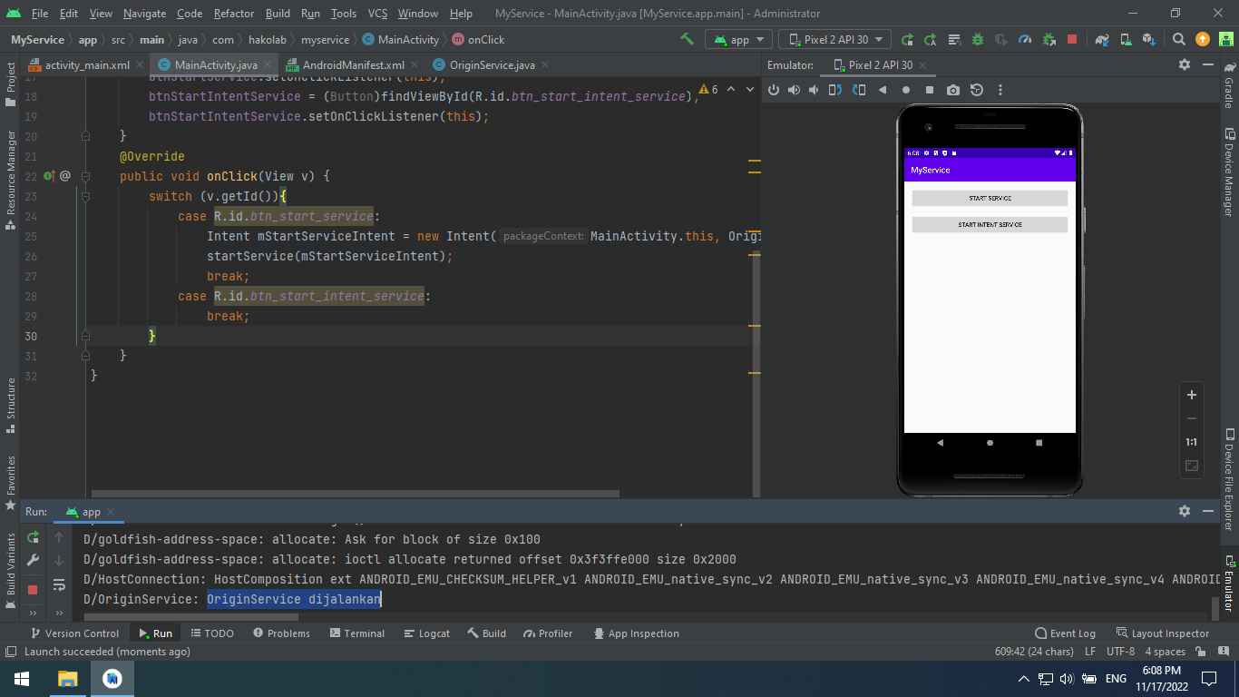

Melengkapi source code: OriginService.java

package com.hakolab.myservice;  
  
import android.app.Service;  
import android.content.Intent;  
import android.os.AsyncTask;  
import android.os.IBinder;  
import android.util.Log;  
  
public class OriginService extends Service {  
 public static final String *ORIGIN_SERVICE* = "OriginService";  
 public OriginService() {  
 }  
 @Override  
 public IBinder onBind(Intent intent) {  
 // *TODO: Return the communication channel to the service.* throw new UnsupportedOperationException("Not yet implemented");  
 }  
 @Override  
 public int onStartCommand(Intent intent, int flags, int startId) {  
 Log.*d*(*ORIGIN_SERVICE*, "OriginService dijalankan");  
 ProcessAsync mProcessAsync = new ProcessAsync();  
 mProcessAsync.execute();  
 return *START_STICKY*;  
 }  
 private class ProcessAsync extends AsyncTask<Void, Void, Void> {  
 @Override  
 protected Void doInBackground(Void... params) {  
 try {  
 Thread.*sleep*(3000);  
 } catch (InterruptedException e) {  
 e.printStackTrace();  
 }  
 return null;  
 }  
 @Override  
 protected void onPostExecute(Void aVoid) {  
 super.onPostExecute(aVoid);  
 Log.*d*(*ORIGIN_SERVICE*, "StopService");  
 stopSelf();  
 }  
 }  
 @Override  
 public void onDestroy() {  
 super.onDestroy();  
 Log.*d*(*ORIGIN_SERVICE*, "onDestroy()");  
 }  
}

Mencoba lagi menjalankan aplikasi. Kemudian, menekan tombol start service:

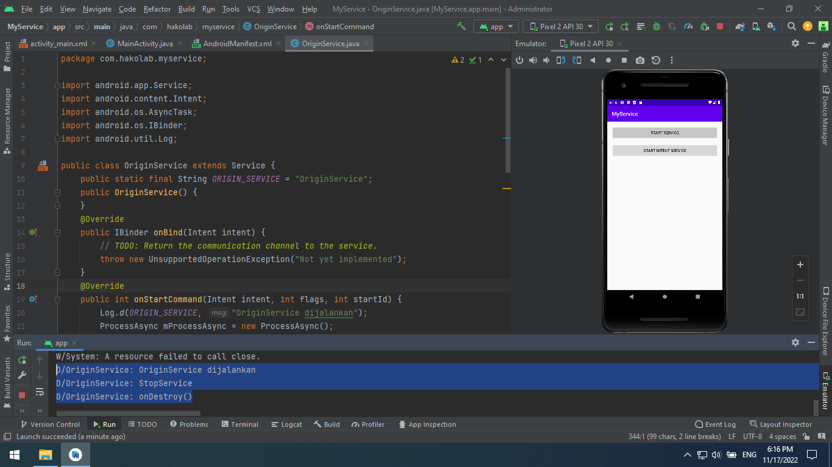

Source Code: DicodingIntentService.java

package com.hakolab.myservice;  
  
import android.app.IntentService;  
import android.content.Intent;  
import android.util.Log;  
  
public class DicodingIntentService extends IntentService {  
 public static String *EXTRA_DURATION* = "extra_duration";  
 public static final String *TAG* = "DicodingIntentService";  
 public DicodingIntentService() {  
 super("DicodingIntentService");  
 }  
 @Override  
 protected void onHandleIntent(Intent intent) {  
 Log.*d*(*TAG*, "onHandleIntent()");  
 if (intent != null) {  
 int duration = intent.getIntExtra(*EXTRA_DURATION*, 0);  
 try {  
 Thread.*sleep*(duration);  
 } catch (InterruptedException e) {  
 e.printStackTrace();  
 Thread.*currentThread*().interrupt();  
 }  
 }  
 }  
 @Override  
 public void onDestroy() {  
 super.onDestroy();  
 Log.*d*(*TAG*, "onDestroy()");  
 }  
}

Menambahkan source code: MainActivity.java method onClick()

@Override  
public void onClick(View v) {  
 switch (v.getId()){  
 case R.id.*btn_start_service*:  
 Intent mStartServiceIntent = new Intent(MainActivity.this, OriginService.class);  
 startService(mStartServiceIntent);  
 break;  
 case R.id.*btn_start_intent_service*:  
 Intent mStartIntentService = new Intent(MainActivity.this, DicodingIntentService.class);  
 mStartIntentService.putExtra(DicodingIntentService.*EXTRA_DURATION*, 5000);  
 startService(mStartIntentService);  
 break;  
 }  
}

Tampilan ketika menjalankan aplikasi dan menekan tombol start intent service:

